Utilization Of Multiple Input Multiple Output In Wireless Communication

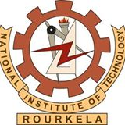

Presented as final year B.Tech Project

By

Sital Prakash

113EC0381

Supervised By:

Dr. Siddharth Deshmukh